By: Sally Phan
Year: 10IT
Model text portrait effect
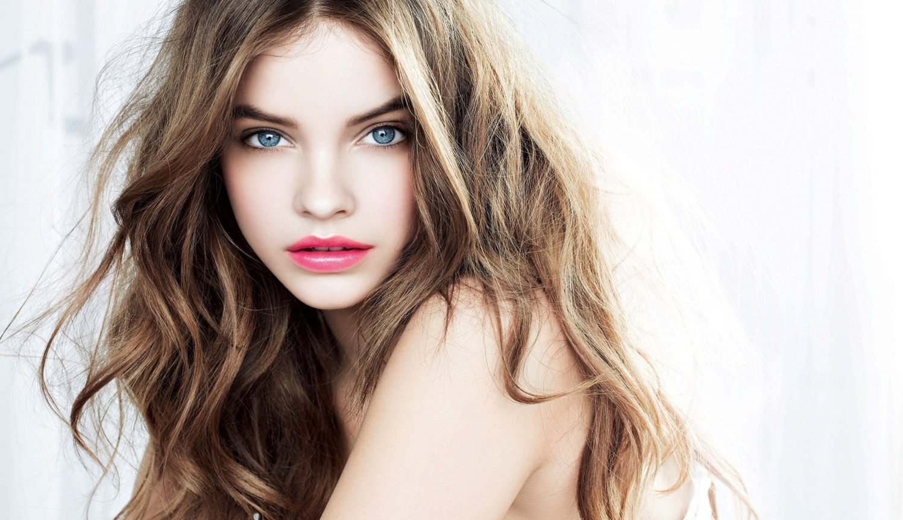

Step 1:

- Open Photoshop with the model and unlock that picture.
- The first thing we have to do is created the new brush with text. Open the new layer and filling the white colour then click on text tool and typing any words you want. I used the word “model’’ and then make it black, use Ctrl + T (or Command + T for Mac) to make it bigger and then enter.

Step 2:

- Go to Edit click on Define Brush Preset then rename a brush “tut brush” and click ok. Let click on Brush and check the new brush on there. After that delete that layer and type another word “love” doing the same thing like before.
- Delete the white layer and create a new layer, put it under the model photo and then filling the black colour. Hide the model photo for now and then create a new layer with name “brush” and another one name “normal brush”. Select 2 new layer and Ctrl + G (or Command + G for Mac) to makes a group.

Step 3:

- Select the “brush” layer then click on Brush tool then click on the new brush “model”, go to option click on Brush to Shape make the shaping around 200% , then click on Shape Dynamics make Size Jitter 100%, then click on Scattering make the Scatter 220% and the Count is 2, then click the Transfer make Opacity Jitter and Flow Jitter is 0%.
- Go to the size to make it bigger and smaller when I need because I used some bigger and some smaller. Put it around the layer from many to a bit.
- Then do the same thing to the “love” brush. Click the model layer and move a bit to the left size, then put many brush on her face to see her face probably.

Step 4:

- Click on the model layer and apply a new layer on that layer, click on the brush choice the first brush make the colour is black and fill around right size of the image.
- Go to the Gradient Map change the colour to Violet, Orange click ok, then put it on Screen then Opacity to 70%.

Step 5:

- Save it in JPG

Here we go:

